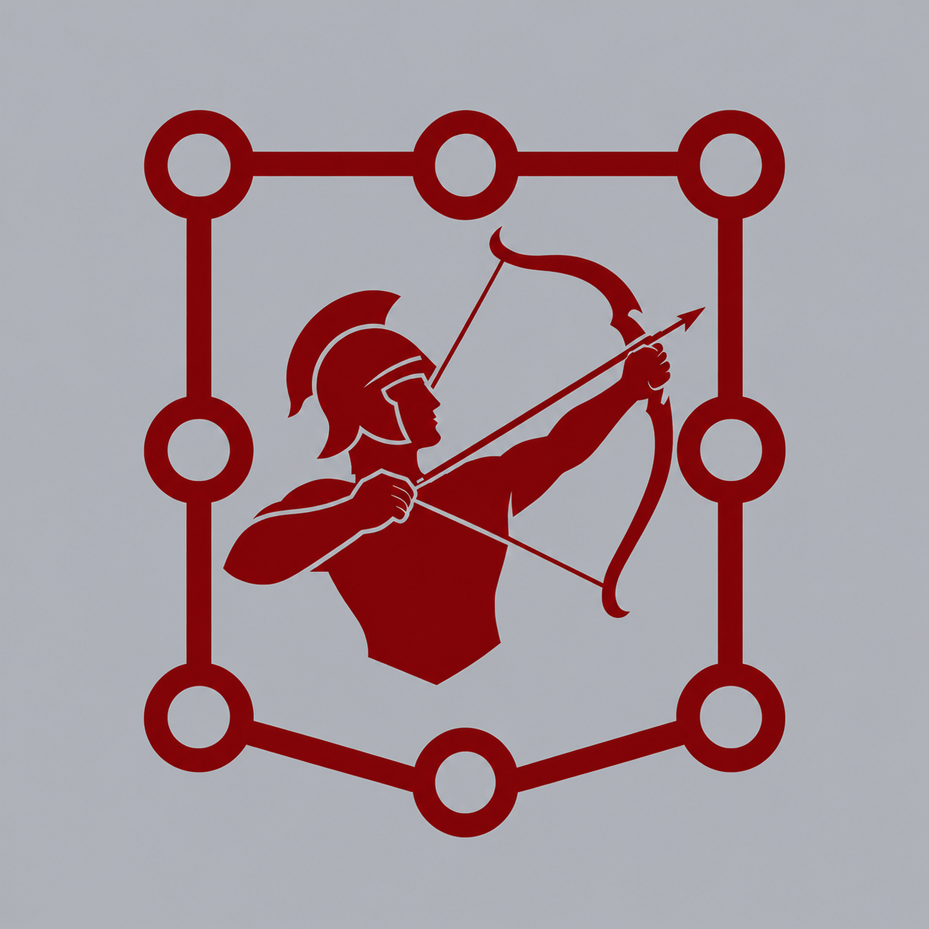 | TACTICAL 10  BUILD YOUR UNIVERSE  Character Equivalence Template
Choose any universe or saga and decide which characters best correspond to the 30 Ancient Greece characters of Tactical 10.
Complete your own equivalence list, then share it with the Tactical 10 community.
Universe / Saga
Created by
ANCIENT GREECE | YOUR UNIVERSE / SAGA
01. Hercules
02. Uranus
03. Hermes
04. Chronos
05. Persephone
06. Athena
07. Atlas
08. Zeus
09. Hades
10. Hephaestus
11. Poseidon
12. Apollo
13. Ares
14. Artemis
15. Thanatos
16. Hypnos
17. Achilles
18. Hera
19. Dionysus
20. Hecate
21. Aphrodite
22. Prometheus
23. Perseus
24. Chimera
25. Medusa
26. Hydra
27. Cerberus
28. Minotaur
29. Hestia
30. Griffin
Share your version: @tactical_10_official

